Seasons in the sun

Press release

12 November 2014
The balmy days of summer are not too far away and, even though Kiwis are currently dealing with unpredictable spring weather, now is the time to get SunSmart.
New Zealanders have an easy-to-use tool that tells them exactly when they need to protect their skin from the sun. The Sun Protection Alert provides simple information that is easy to act on and specific to each area of the country for that day. Sun safety messages such as ‘seek shade’ and ‘reapply sunscreen’ are included in the Sun Protection Alert and change regularly to reflect weather forecasts.
“It is important not to underestimate the power of the sun at this time of the year and to remember that it’s not the sun’s heat that burns but ultraviolet radiation (UVR),” said Kath Blair, the Health Promotion Agency’s (HPA's) SunSmart manager.
“UVR is at its highest between September and April, especially between 10am and 4pm. It’s really important to slip, slop, slap and wrap – slip on a shirt or into the shade, slop on plenty of broad-spectrum sunscreen of at least SPF 30, slap on a hat, and wrap on a pair of sunglasses.
“There is an increased risk of sunburn if we aren’t SunSmart. Sunburn is a big concern because it increases the risk of melanoma skin cancer later in life. About 300 New Zealanders die from melanoma skin cancer every year. Skin cancer is largely preventable by taking simple measures to protect ourselves from the sun.,” Ms Blair said.
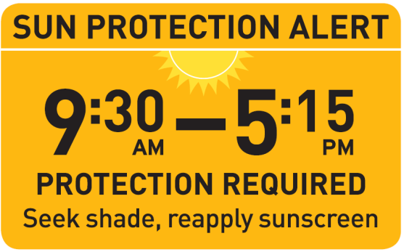
HPA has worked with MetService and NIWA to produce a range of ways the sun protection information can be easily accessed by the public. This includes having the Sun Protection Alert on MetService’s Towns and Cities smartphone weather apps. It is also available in daily newspapers and on pages throughout the Towns and Cities, Rural, Marine and Surf sections of metservice.com. A version can also be integrated into business websites or intranets for clients and employees to use to keep themselves safe in the sun.
ENDS
For further information or comment contact
HPA SunSmart Manager, Kath Blair on 021 530 239.

