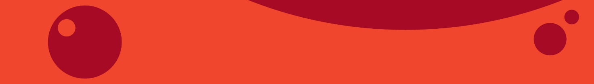
Measles campaign media release template
This draft media release lets you tailor the message for your own local media. Fill in gaps (in square brackets) with local details, stories and any photos you have to enrich your communications and make it relevant for your region.
Protect yourself and your whānau from measles at [name of your event]
Young people from [name of your city, town or rohe] can get immunised against measles for free at [insert name of your event] on [date].
Lots of people aged between 15 and 30 years missed out on getting fully immunised when they were children. This means they are at risk of catching and spreading measles.
Measles spreads fast. It can make you really sick and even put you in hospital. Getting immunised means you’re protected and won’t miss out on earning, learning or having fun.
That’s why the team from [insert name of your agency] is making it easy for your teenagers and young adults to get immunised with a pop-up immunisation clinic at [location or event].
Open from [dates and times], you can go along to see the team and get your free measles mumps and rubella (MMR) vaccine on the spot – or get answers to any questions you have about vaccinations.
[name] is one of the vaccination staff who will be there on the day. S/he says lots of the young people s/he talks to don’t know if they are immunised: “You can find out by asking your whānau or by talking to your health professional, but if you don’t know, don’t worry. Come and see us and we can give you the vaccine – it’s okay to have it again. It’s pretty quick and then you know you’re protected.”
Clinics like this one are popping up all over Aotearoa – it’s all part of a campaign to protect young people from measles and prevent another outbreak of the disease.

The 2019 outbreak of measles infected more than 2,000 people, and 700 had to go to hospital. Māori and Pacific communities were particularly affected. The Ministry of Health says we need 95 percent of people to be immune to reach ‘community immunity’ (sometimes known as ‘herd immunity’) and help stop future outbreaks.
[include quote from local person backing the campaign. If not available, use the following quote from Nikki Turner, Director of the Immunisation Advisory Centre] “Getting immunised is about being a kaitiaki for your whānau,” says [influencer backing the campaign]. “When you get vaccinated you look after your own health and help prevent the spread of the disease. Measles can be really serious for our young pēpi and tamariki, so it’s vitally important we get vaccinated to keep them and future generations safe.”
Measles spreads fast. “But we have a tried and tested vaccine. It’s about protecting yourself and being a guardian of the future,” says [name of person quoted above].
Not able to make it along to [event]? You can get immunised for free at participating pharmacies. Just turn up, you don’t need an appointment or to bring anything with you. The pharmacist will take you to a private space in the pharmacy to do this. You’ll need to wait for 20 minutes after.
You can also ask your doctor for a free measles immunisation.
Find out more at ProtectAgainstMeasles.org.nz – includes a Factsheet (translated into other languages).
